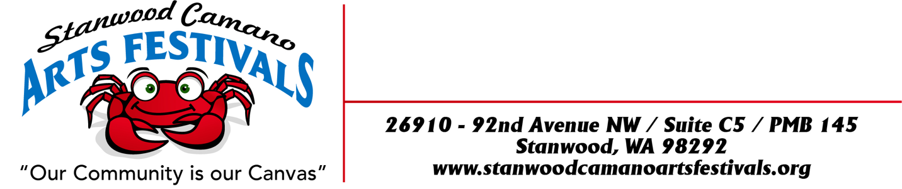
19th Annual
APPLICATION
“CAMANO ISLAND MOTHERS DAY ART FESTIVAL”
ON CAMANO IS, WA
“Our Community Is Our Canvas”

MOTHERS DAY WEEKEND
MAY 9TH, 10^{TH,} 11TH 2025
Only one weekend this year
LOCATION:
Camano Commons, grassy courtyard behind Camano Island Coffee Roasters and Camano Island Marketplace, 848 N. Sunrise Blvd, Camano Island, WA 98282

FESTIVAL DATES & TIMES:
Friday May 9th, Saturday 10th & Sunday 11th 10:00am to 5:00pm

SET UP TIMES:
Thursday May 8th 12:00pm to 7:00pm
Friday May 9th 7:00am to 9:00am
Please notify Sally if you plan on setting up on Friday May 9th
You will be sent an email a couple days before the festival with your check in time and booth number.

BOOTH FEES: due by April 24th, 2025. Limited Booth space
Application Fee: $15.00
Single 10 x 10 $150.00
Double 10 x 20 $300.00
Booth locations will be assigned when you check in.
There will be no refunds after April 25th, 2025 and we apologize in advance that there can be no exceptions to this policy.

*Double Booths: We have a very limited number of double booth spaces available. If you would like to request one, please send an email to sallyprayscaf@yahoo.com We will do our best to
accommodate your request during our mapping process.
BOOTH GUIDELINES:
This is an outdoor event and your booth must be designed to withstand wind and inclement weather. All tents MUST have weights! Each tent must have at least 50 pounds on each leg. The tents must have all 4 sides on their tents at night. We can get some big winds being on the water, at night especially!
No stakes or anything can be inserted into the grass for weights. All Weights must be above ground due to sprinkler system or blacktop. All booths must be kept open till closing times. Event will be held, regardless of weather.

REQUIREMENT AND RESTRICTIONS:
*Vendors will be staffing their own booth, collecting their own money and paying their own taxes.
*Vendors must obtain all state and local tax permits necessary for operation. Sales tax is 8.7%.
*No onsite food preparation is allowed. Only packaged food to be sold on site such as jams, jellies, sauces, salsa, breads, seasonings and etc. No coffee other that Camano Island Roasters is to be sold. In selling such products will agree to package, sell and sample in according to Washington State, County, City and Federal Regulations and have necessary permits.
*Vendors must provide their own booth pieces complimentary to your craft. Responsible for cleaning up of your own litter from your space.
*No smoking or “hawking” will be allowed in the vicinity of your booth.
*Vendors agree that the management and Stanwood Camano Arts Festivals shall be held blameless and not financially liable for any personal injury to the exhibitor or his/her helper. Management is not liable for any merchandise or property stolen or damaged in any way. The vendor assumes all responsibility.
*All pertinent fire codes, laws, ordinances and regulations pertaining to health, fire prevention and public safety shall be strictly obeyed.
*Vendors shall park at the “Park and Ride” area. No firearms allowed.

DEADLINE TO APPLY: Monday April 17th, 2025… Please send separate checks, if applying by mail, onecheck for jury fee, one check for booth fee along with three pictures of art and one of your booth set up for the festival if you would like to participate. If you are not juried into our festival your booth fee check will be returned.
Selected Artist Notified Friday April 21st, Booth purchase deadline April 24th, No booth fee refunds after April 25th, 2025. There is a limited amount of booth spaces where we set up for the Festival so get your Application in ASAP.

No stakes or anything can be inserted into the grass for weights. All Weights must be above ground due to sprinkler system or blacktop.

ARTIST APPLICATION ON THE NEXT PAGE

ARTISTS APPLICATION FORM
CELEBRATING OUR 19th Annual
“CAMANO ISLAND MOTHERS DAY ART FESTIVAL” On CAMANO ISLAND, WA
MAY 9TH, 10^{TH,} 11TH 2025
Only one weekend this year

BUSINESS NAME:___________________ARTIST NAME: ________________________________

ADDRESS: ______________________________ CITY: ____________ STATE: ____ ZIP: _______

EMAIL: _________________________________ WEBSITE: ______________________________

PHONE: HOME/BUSINESS _________________ CELL: __________________________________

UBI #: (MANDATORY FOR ALL ACCEPTED ENTRANTS) _________________________________

PLEASE INCLUDE: 3 PICTURES OF YOUR ART WORK AND 1 PICTURE OF YOUR BOOTH ALONG
WITH A DESCRIPTION OF YOUR WORK THAT YOU ARE PLANNING TO SELL.
BOOTH FEES:
Please send separate checks to apply if applying by mail, one for jury fee, one for booth fee along with three pictures of art and one of your booth. If you are not juried into our festival your booth fee check will be returned

Application Fee: $15.00 $ 15.00 ______Separate Checks
Single 10 x 10 $ 150.00 $150.00 ______Separate Checks
Single 10 x 20 $300.00 $ 300.00 ______
TOTAL $ ENCLOSED: ___________________
DATE: __________________ SIGNATURE: ___________________________________________
Make checks out to: Stanwood Camano Arts Festivals
And mail to 26910 – 92nd Ave. NW
Suite C5 - PMB 145
Stanwood, WA 98292
Sally Prays Phone: 425-773-0313 cell EMAIL: sallyprayscaf@yahoo.com
Rvs 12-31-25sp

